**TRANSFOMER LIFE PREDICTION MAJOR CONSTRAIN**

1] Dissolved Gas Analysis (DGA)

**. Gas Concentrations (ppm - Parts Per Million)**

* **Hydrogen (H₂)** → Partial discharge
* **Methane (CH₄)** → Overheating
* **Ethane (C₂H₆)** → Thermal degradation
* **Ethylene (C₂H₄)** → High-temperature faults
* **Acetylene (C₂H₂)** → Electrical arcing
* **Carbon Monoxide (CO)** → Insulation paper degradation
* **Carbon Dioxide (CO₂)** → Insulation overheating

**2. Gas Ratios :-**

* **CH₄ / H₂** → Detects partial discharge
* **C₂H₂ / C₂H₄** → Differentiates arcing vs. overheating
* **C₂H₄ / C₂H₆** → Classifies thermal faults
* **CO₂ / CO** → Indicates insulation degradation

**3. Transformer Operational Data**

* **Date of DGA Test**
* **Transformer Age (Years)**
* **Load History (% of Rated Load)**
* **Oil Change History (Yes/No)**
* **Last Maintenance Date**

**4. Target Labels for Prediction**

* **Fault Type** (Normal, Partial Discharge, Thermal Fault, Electrical Arcing)

2] Partial Discharge Measurement

**1. Electrical Discharge Parameters**

* **Apparent Charge (pC - PicoCoulombs)** → Strength of discharge
* **Discharge Energy (µJ - MicroJoules)** → Energy released per discharge event
* **Discharge Repetition Rate (PPS - Pulses Per Second)** → Frequency of PD occurrences
* **Phase-Resolved Partial Discharge (PRPD) Pattern** → Discharge behavior over AC cycle

**2. PD Location & Intensity Indicators**

* **PD Inception Voltage (PDIV - kV)** → Voltage level where PD starts
* **PD Extinction Voltage (PDEV - kV)** → Voltage where PD stops
* **PD Pulse Amplitude (mV or dB)** → Strength of individual PD pulses

**3. Transformer Operational Data**

* **Transformer Age (Years)**
* **Load (% of Rated Load)** → Higher loads may trigger PD
* **Insulation Condition (Good/Moderate/Poor)**
* **Previous Maintenance Date**

**4. Environmental & Oil Condition Factors**

* **Moisture Content in Oil (% or ppm)** → High moisture increases PD risk
* **Temperature (°C)** → Affects insulation performance
* **Dissipation Factor (Tan Delta)** → Measures insulation degradation

**5. Target Labels for Prediction**

* **PD Severity Level** (Low, Medium, High)

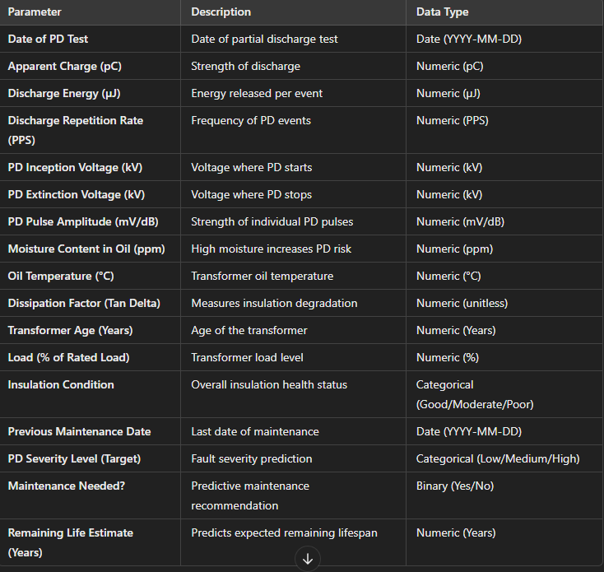

**3] Dissipation Factor (Tan Delta) and Capacitance Measurement**

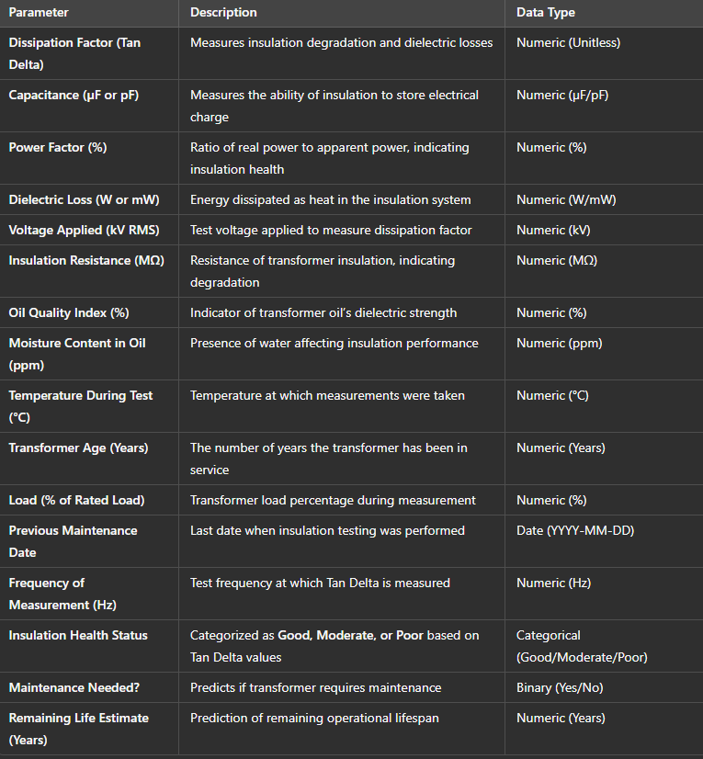

**# Target Variables for Prediction**

**Insulation Health Status** – Categorized as **Good, Moderate, or Poor** based on Tan Delta values. *(Categorical - Good/Moderate/Poor)*

**4]Insulation Resistance Measurement**

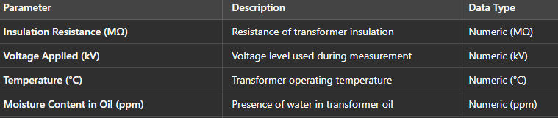

**# Target Variables for Prediction**

Insulation Resistance Measurement → Insulation Health Status (*Good, Moderate, Poor*)

**5]Winding Resistance Measurement**

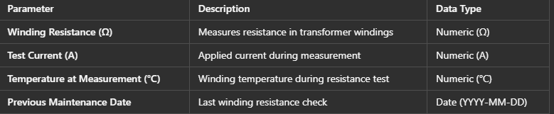

**# Target Variables for Prediction**

Winding Resistance Measurement → Winding Condition (*Normal, Degraded, Critical*)

**• 6]Dielectric constant Measurement**

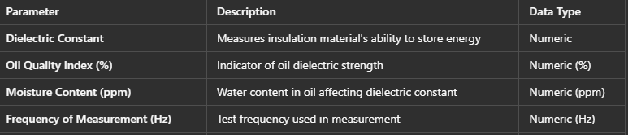

**# Target Variables for Prediction**

Dielectric Constant Measurement → Insulation Efficiency (*High, Medium, Low*)

**7]Oil and Winding Temperature Monitoring**

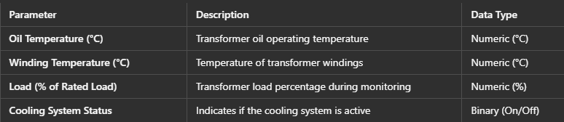

**# Target Variables for Prediction**

Oil and Winding Temperature Monitoring → Overheating Risk (*Low, Moderate, High*)

**8]Frequency Response Analysis**

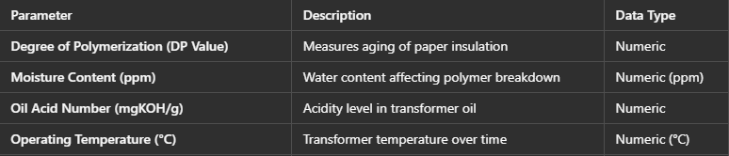

**# Target Variables for Prediction.**

Frequency Response Analysis → Structural Integrity (*Stable, Minor Deviation, Major Deviation)*

**9]Degree of Polymerization Measurement**

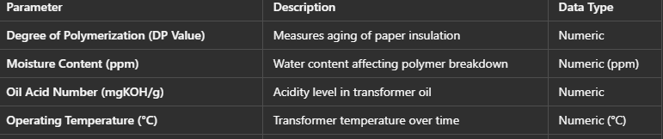

**# Target Variables for Prediction**

Degree of Polymerization Measurement → Paper Insulation Condition (*Good, Aged, Critical*)

**10]Moisture or Water Particle Measurement**

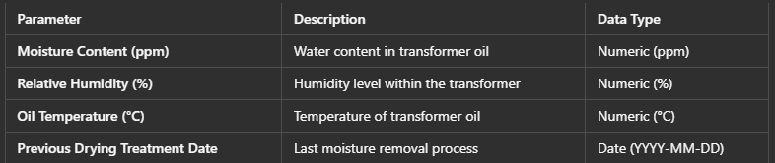

**# Target Variables for Prediction**

Moisture or Water Particle Measurement → Moisture Risk Level (*Low, Medium, High)*